Data Visualization Dashboard Report

Prepared By: Samruddhi Amol Mhamane (202501110050)
Snehal Yogesh Joshi (202501110055)

Project Title: Global Superstore Executive Dashboard using Power BI
Subject: Data Visualization
Software Used: Microsoft Power BI
Dataset: Global Superstore Dataset

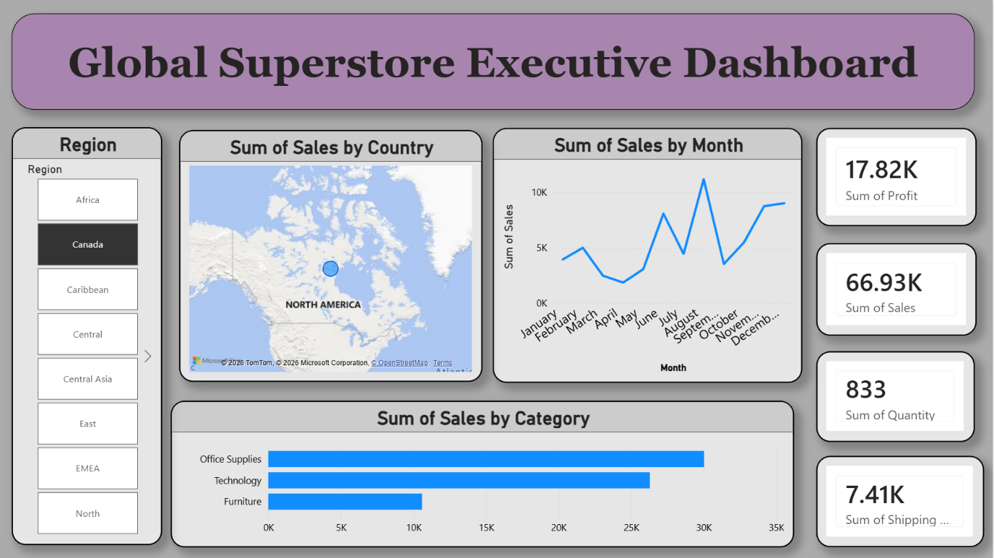

Index

- Introduction
- Objectives
- Tools & Technologies Used
- Dataset Description
- Dashboard Overview
- Executive Summary Dashboard
- Trend & Growth Analysis
- Sales Breakdown Analysis
- Market Analysis Dashboard
- AI Insights Dashboard
- Features Implemented
- Key Insights
- Conclusion

1. Introduction
This project focuses on analyzing sales data using Microsoft Power BI. The Global Superstore dataset was used to create interactive dashboards for sales, profit, quantity, categories, regions, and yearly growth analysis.
The main aim of the project is to convert raw data into meaningful visual reports that help in understanding business performance and trends. Various Power BI features such as charts, maps, KPI cards, slicers, drill-through, and AI visuals were used to make the dashboards interactive and informative.

2. Objectives
- To visualize sales and profit data effectively.
- To analyze category-wise and region-wise performance.
- To study yearly and monthly sales trends.
- To identify top-performing products and markets.
- To implement interactive Power BI features like slicers, bookmarks, drill-through, and AI visuals.

3. Tools & Technologies Used
- Microsoft Power BI
- Power Query Editor
- DAX (Data Analysis Expressions)
- Global Superstore Dataset

4. Dataset Description
The dataset contains:
- Product details
- Sales data
- Profit values
- Quantity sold
- Discount information
- Shipping mode
- Region and market information
- Order and ship dates
The data was cleaned and transformed before visualization.

5. Dashboard Overview
The project contains multiple dashboards for analyzing business performance from different perspectives such as executive summary, sales trends, market analysis, and category analysis.
Different visualizations like KPI cards, line charts, pie charts, maps, word clouds, and decomposition trees were used to represent the data effectively. Interactive filters and slicers allow users to explore the data easily and gain better insights.

6. Executive Summary Dashboard
This dashboard provides an overview of overall business performance including sales, profit, quantity, shipping cost, and category-wise sales.

Features:
- Region slicer
- KPI Cards
- Line chart for monthly sales
- Bar chart for category sales
- Map visualization

Key Insights:
- Office Supplies category generated the highest sales.
- Canada region showed strong sales performance.
- Sales increased towards the end of the year.



7. Trend & Growth Analysis
This dashboard analyzes year-wise and month-wise sales growth.
Features:
- Year slicer
- YoY Growth KPI
- Sales YTD and QTD
- Monthly trend comparison
- Sales table with MoM growth
Key Insights:
- Sales showed consistent yearly growth.
- Highest sales were observed during the last quarter.
- Positive Year-over-Year growth was achieved.

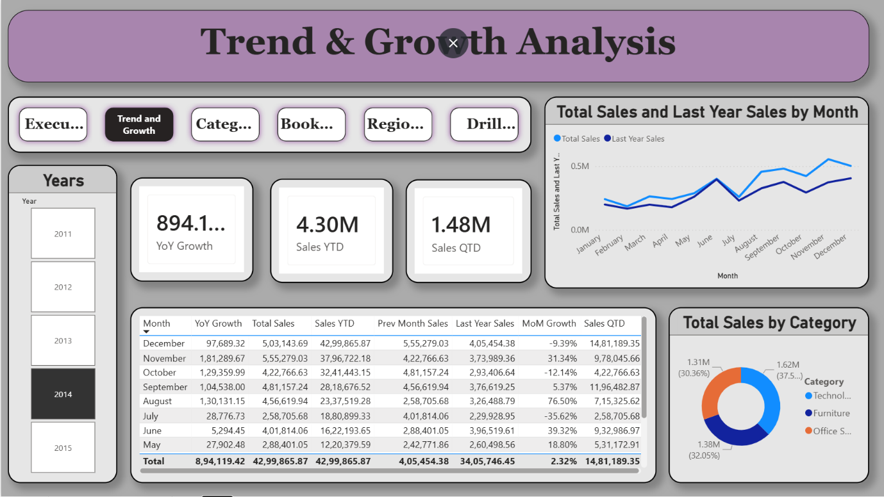

8. Sales Breakdown Analysis
This dashboard provides detailed decomposition of sales based on category, sub-category, region, segment, and ship mode.
Features:
- Decomposition Tree
- Interactive filters
- Drill-down analysis
Key Insights:
- Technology category contributed major sales.
- Phones sub-category had highest revenue contribution.
- Standard Class shipping mode was mostly used.

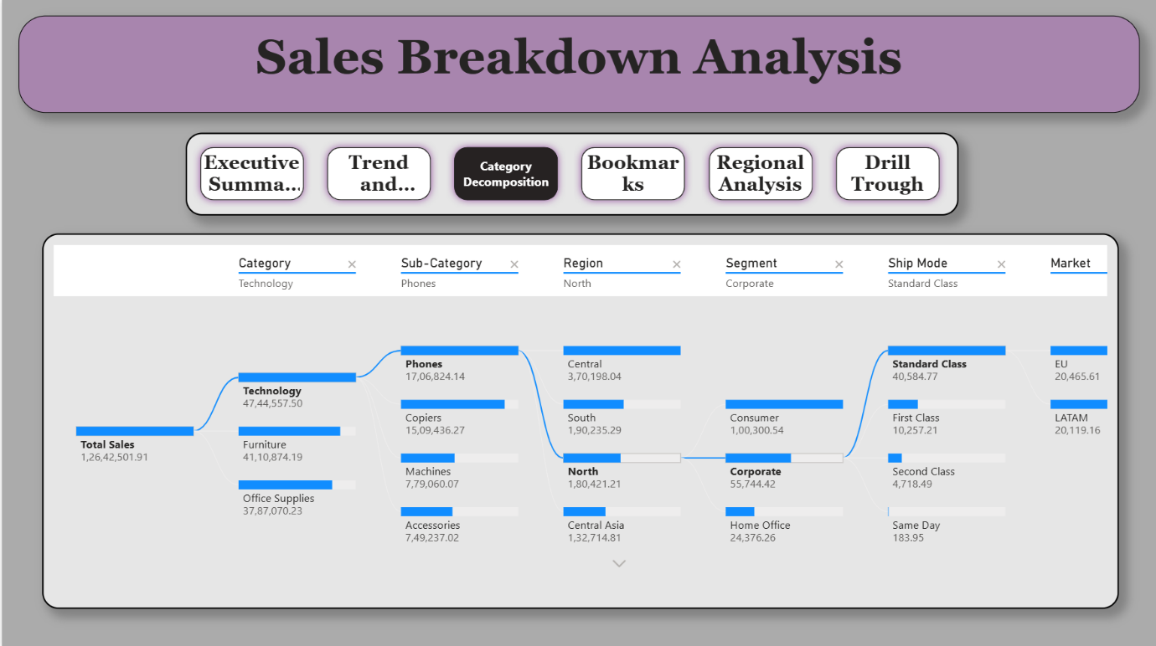

9. Market Analysis Dashboard
This dashboard focuses on regional and category-based market performance.

Features:
- Region filter
- Ship mode filter
- Category filter
- State-wise map visualization
- Word cloud for sub-category analysis

Key Insights:
- Copiers and Phones were dominant products.
- North Asia market showed strong performance.
- Same Day shipping mode had lower usage.

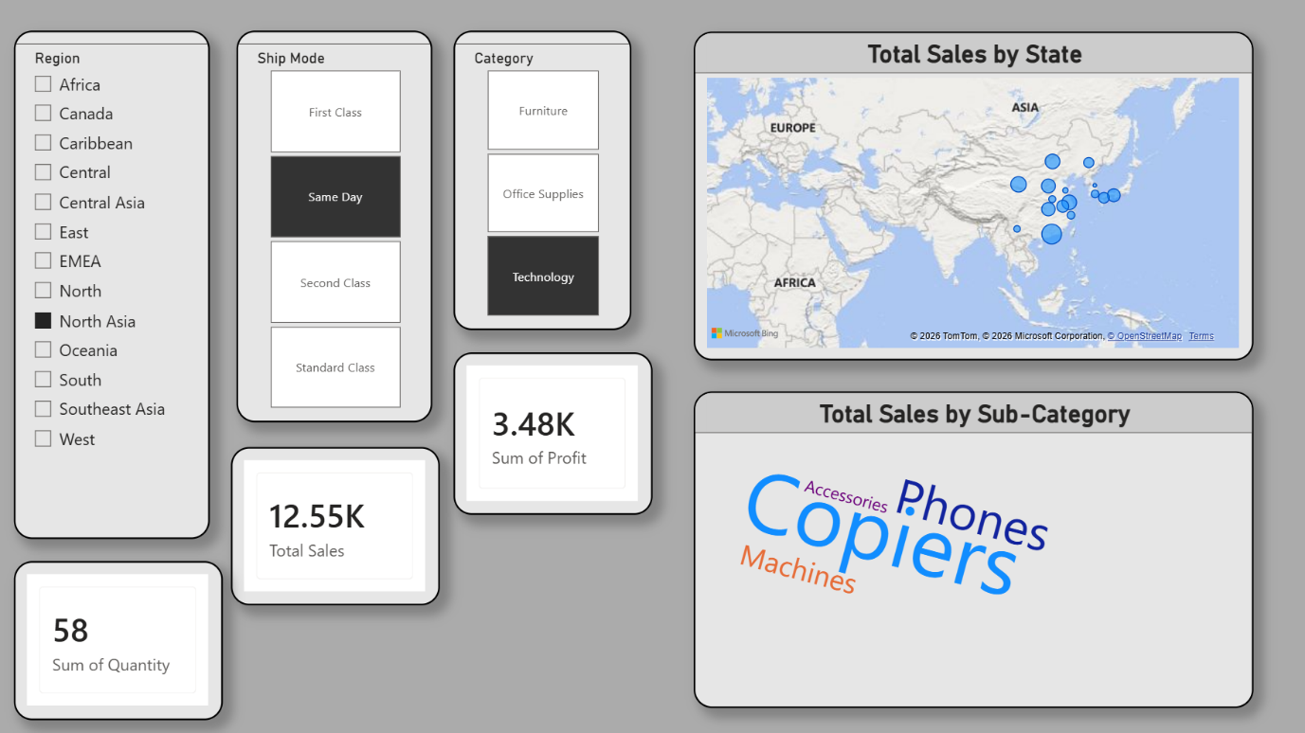

10. AI Insights Dashboard
This dashboard uses Power BI AI visuals and Q&A features.

Features:
- Q&A Visual
- Smart insights
- Profit vs Sales comparison
- Discount analysis
- Gauge chart for total sales

Key Insights:
- Sales and profit are positively correlated.
- Majority sales were generated with low discounts.
- AI Q&A helps users quickly query data.

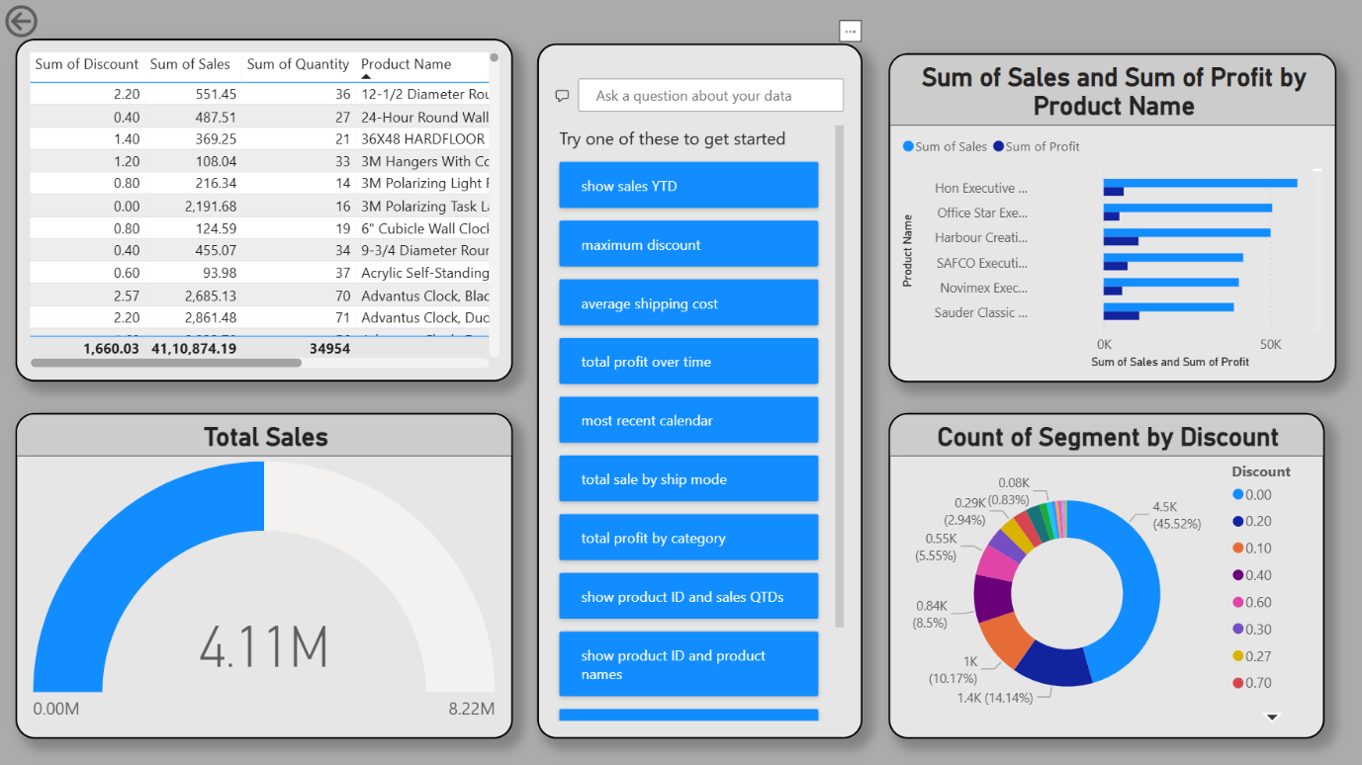

11. Features Implemented
The following Power BI features were implemented:
- Slicers
- KPI Cards
- Line Charts
- Pie Charts
- Donut Charts
- Maps
- Word Cloud
- Decomposition Tree
- Drill Through
- Bookmarks
- AI Q&A Visuals

12. Key Insights
- Technology products generated high profits.
- Sales increased significantly in 2014.
- Office Supplies category had maximum sales contribution.
- Standard Class shipping was preferred by customers.
- North Asia and Canada markets performed well.

13. Conclusion
The Global Superstore Dashboard project successfully demonstrates the use of Power BI for data visualization and business analysis. The dashboards helped in understanding sales trends, profit performance, category contributions, and regional analysis.
Interactive features such as slicers, bookmarks, drill-through, and AI visuals improved the usability of the report. Overall, the project shows how Power BI can help businesses make better data-driven decisions through effective visualization and analysis.

